Supermarket is the Chef community’s central clearing house for sharing cookbooks, tools, and plugins. It is a place for Chef community members to download community cookbooks, collaborate on cookbooks, and upload cookbooks to be used by other community members. It is also the place to share information about tools that improve Chef’s ecosystem. The Supermarket makes it easier to start participating in Chef’s open source projects by allowing individuals and corporations to sign and manage their Contributor License Agreements (CLA’s). Check out the [Supermarket Announcement Blog Post](http://chefio.wpengine.com/2014/03/24/chef-supermarket-the-new-community-site/) for more information.

There are two versions of Supermarket available today.

Public Supermarket

This is available at the [Chef Supermarket site](https://supermarket.chef.io/). This is an open source project, you can find and contribute to the [repo on GitHub](https://github.com/chef/supermarket).

Private Supermarket

There is also a version of Supermarket that can be run privately in your own infrastructure. This guide will not cover the private version of Supermarket, but many of the same principles will apply. Stay tuned for an Private Supermarket guide!

Getting Started with Supermarket

There are a few things you will need to work with Supermarket.

Knife

You will need Knife to interact with the Supermarket.

The easiest way to get Knife (along with many other tools needed to use both Supermarket and Chef) is through the [Chef Development Kit](https://downloads.chef.io/chef-dk/).

Make sure you have a [knife.rb](https://docs.chef.io/config_rb_knife.html) config file setup.

This guide will take you through the basics of using Knife and Supermarket. For more information on the various commands and options, please see the full [Knife cookbook site documentation](https://docs.chef.io/knife_cookbook_site.html).

Browsing the Supermarket

You can now take several actions to browse the community cookbooks available on the Supermarket site.

List

To see a list of all community cookbooks available from Supermarket, run the following:

$ knife cookbook site list

This will return lots of output similar to:

1password minecraft

301 mineos

7-zip minidlna

AWS\_see\_spots\_run minitest

AmazonEC2Tag minitest-handler

Appfirst-Cookbook mirage

CVE-2014-3566-poodle mlocate

CVE-2015-0235 mod\_security

Obfsproxy mod\_security2

R modcloth-hubot

Rstats modcloth-nad

SysinternalsBginfo modman

VRTSralus modules

abiquo mogilefs

acadock mongodb

accel-ppp mongodb-10gen

accounts mongodb-agents

accumulator monit

[etc]

Search

Looking for a particular cookbook? The most downloaded cookbook as of February 2015 is the mysql cookbook. If I wanted to search for this cookbook I would use a command similar to this:

$ knife cookbook site search mysql

Which will return output similar to this:

mysql:

cookbook: http://cookbooks.opscode.com/api/v1/cookbooks/mysql

cookbook\_description: Provides mysql\_service, mysql\_config, and mysql\_client resources

cookbook\_maintainer: chef

cookbook\_name: mysql

mysql-apt-config:

cookbook: http://cookbooks.opscode.com/api/v1/cookbooks/mysql-apt-config

cookbook\_description: Installs/Configures mysql-apt-config

cookbook\_maintainer: tata

cookbook\_name: mysql-apt-config

mysql-multi:

cookbook: http://cookbooks.opscode.com/api/v1/cookbooks/mysql-multi

cookbook\_description: MySQL replication wrapper cookbook

cookbook\_maintainer: rackops

cookbook\_name: mysql-multi

Let’s take a closer look at that first mysql cookbook.

Show

To view more information about a particular cookbook, run the following:

$ knife cookbook site show mysql

Which will return input similar to this:

average\_rating:

category: Other

created\_at: 2009-10-28T19:16:54.000Z

deprecated: false

description: Provides mysql\_service, mysql\_config, and mysql\_client resources

external\_url: http://github.com/opscode-cookbooks/mysql

foodcritic_failure: true

issues\_url:

latest\_version: http://cookbooks.opscode.com/api/v1/cookbooks/mysql/versions/6.0.15

maintainer: chef

metrics:

downloads:

total: 79275449

versions:

0.10.0: 927561

0.15.0: 927536

0.20.0: 927321

0.21.0: 927298

0.21.1: 927311

0.21.2: 927424

0.21.3: 927441

0.21.5: 927326

0.22.0: 927297

0.23.0: 927353

0.23.1: 927862

0.24.0: 927316

If you want to take a look at a specific version of a cookbook, include it in the command like this:

$ knife cookbook site show mysql 0.10.0

Which will return output similar to:

average\_rating:

cookbook: http://cookbooks.opscode.com/api/v1/cookbooks/mysql

file: http://cookbooks.opscode.com/api/v1/cookbooks/mysql/versions/0.10.0/download

license: Apache 2.0

tarball\_file\_size: 7010

version: 0.10.0

Downloading and Installing from the Supermarket

Ready to downlad and install a cookbook from the community site?

Download

To download a cookbook as a tar.gz archive and place it in the current working directory, use the download command.

$ knife cookbook site download mysql

Install

Installing a cookbook is similar to downloading it, but rather than saving the cookbook as a tar.gz, it extracts the cookbook and sets up a git branch so you can keep it up to date with the original cookbook. See this [Stack Overflow](http://stackoverflow.com/a/15075143) for an excellent explanation.

It also resolves dependencies and creates a new branch for each of the dependent cookbooks.

$ knife cookbook site install mysql

NOTE: If you receive the error “ERROR: IOError: Cannot open or read /Users/nshamrell/chef-repo/cookbooks/mysql/metadata.rb”, check which version of knife you are using with:

$ knife -v

If it is lower than Chef: 12.0.2, you will need to update your version of Knife. However, if you are using Chef DK and rvm, try running this command:

$ rvm use system

Then retry

$ knife cookbook site install mysql

Uploading to the Supermarket

Now let’s upload a cookbook to the Supermarket. If you have a cookbook of your own you would like to use, please do! If you’d like some guidance in creating a very basic cookbook of you own to practice uploading to the Supermarket, see the “Create Cookbook” section of [this section of the Supermarket Docs](https://docs.chef.io/supermarket.html#create-cookbook).

Share

There are a few things you’ll need in place before you can upload your cookbook to the Supermarket.  
First, take a look at your knife.rb configuration file. Mine lives at .chef/knife.rb.

You will need to have lines similar to this in the config file. If you don’t already have them, please add them in.

node\_name "nellshamrell" # Replace with the login name you use to login to the Supermarket.

client\_key "#{ENV['HOME']}/.chef/client.pem" # Define the path to wherever your client.pem file lives. This is the key you generated when you signed up for a Chef account.

cookbook\_path [ '/Users/nshamrell/Projects/my\_chef\_repo/cookbooks' ] # Directory where the cookbook you're uploading resides.

We also recommend that you add both a ‘source\_url’ and ‘issues\_url’ in your cookbooks’ metadata. Then, when your cookbook appears on Supermarket, it will also display a link to your cookbook’s source (i.e. a GitHub repo) and issues (i.e. GitHub issues for your repo).

Then use this command to upload the cookbook to the Supermarket!

$ knife cookbook site share "my\_apache2\_cookbook" "Web Servers"

Notice that I defined the Supermarket category my cookbook should be in – in this case, “Web Servers”. Other categories you can use are “Databases”, “Process Management”, “Monitoring & Trending”, “Programming Languages”, “Package Management”, “Applications”, “Networking”, “Operating Systems & Virtualization”, “Utilities”, or “Other”.

Stove

[Stove](https://github.com/sethvargo/stove) is an alternate tool for sharing cookbooks. For more information, please see the [project GitHub page](https://github.com/sethvargo/stove).

Unshare

Should you ever need to unshare a cookbook from the Supermarket, you can use the “unshare” command to do so.

$ knife cookbook site unshare my\_apache2\_cookbook

This will remove your cookbook from the Supermarket site.

If you receive an error which looks like this:

ERROR: Invalid Redirect: DELETE request was redirected from https://supermarket.getchef.com/api/v1/cookbooks/my\_apache2\_cookbook to https://supermarket.chef.io/api/v1/cookbooks/my\_apache2\_cookbook. Only GET and HEAD support redirects.

Change your server location in knife.rb to the server's FQDN to avoid unwanted redirection

## Sample Tomcat7 cookbook downloading from Chef Supermarket

Go to you chef workstation

Open chef-repo and go to cookbooks folder

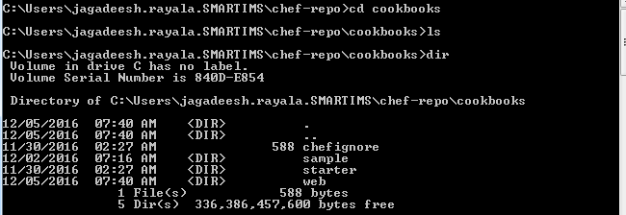

Download tomcat7 cookbook from chef supermarket (<https://supermarket.chef.io/cookbooks>)

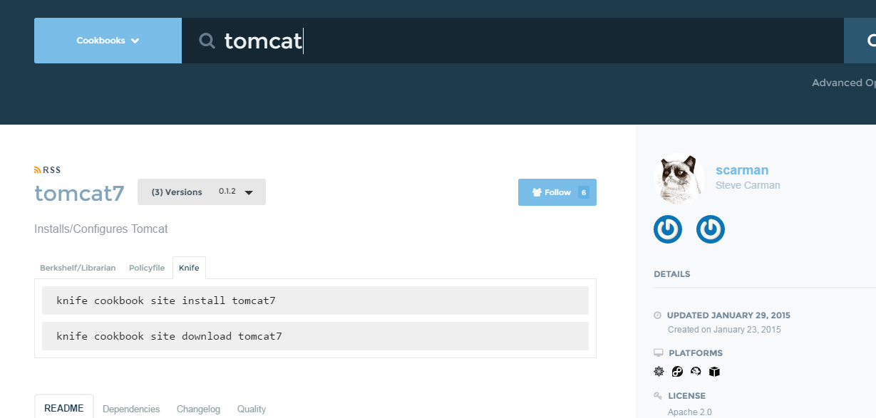

Run below command in your cookbook folder

knife cookbook site install tomcat7

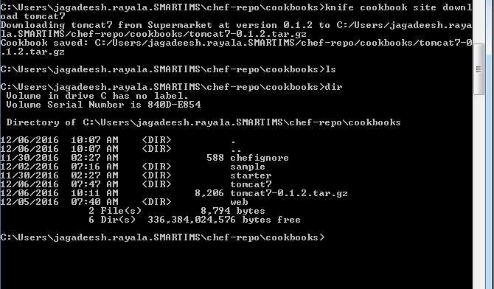

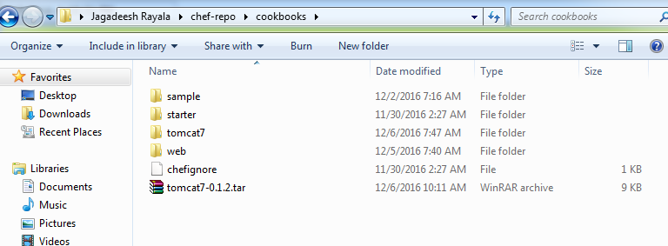

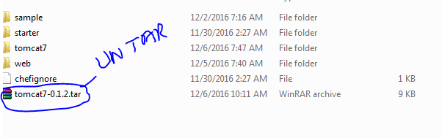

After extracting you will see below folder



Under this folder you will see folder name tomcat7

Cut and paste that folder on cookbooks directory



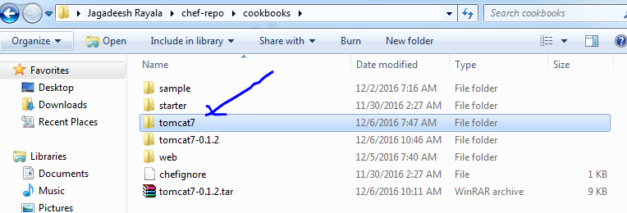

After that remove tomcat7-0.1.2



Then go to tomcat7 cookbook folder and run below command

C:\Users\jagadeesh.rayala.SMARTIMS\chef-repo\cookbooks> berks install

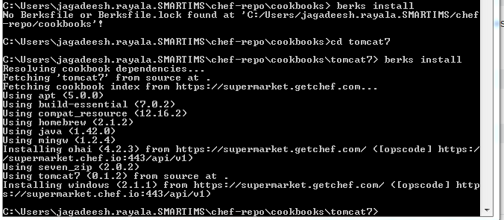

All the Downloaded cookbooks under you home directory

Cd /.berkshelf/cookbooks/

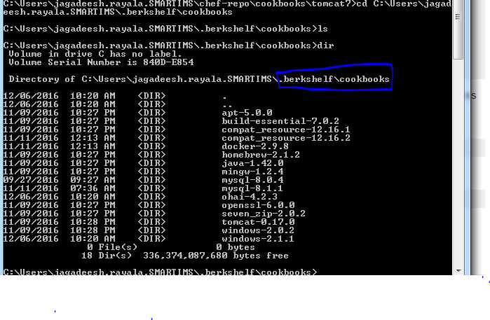

Now go to your tomcat7 cookbook folder and upload cookbook to your chef server using below commad

C:\Users\jagadeesh.rayala.SMARTIMS\chef-repo\cookbooks\tomcat7>berks upload

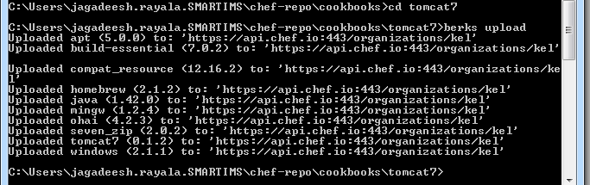

On chef server side you can view below cookbooks

